# SCHOOL OF TECHNOLOGY MANAGEMENT & ENGINEERING

# NMIMS INDORE

cid:image001.jpg@01D74C1B.9B66EA00

## Mini Project Report on

“topic”

Session (2022-2023)

**Subject**: Web Programming

**Submitted By: Guided By:**

*name Faculty Name*

*(Course & Sem) Designation*

**LIST OF FIGURES (if applicable)**

|  |  |  |
| --- | --- | --- |
| **Figure No** | **Figure Title** | **Page No** |
|  |  |  |
|  |  |  |

**LIST OF TABLES (if applicable)**

|  |  |  |
| --- | --- | --- |
| **Table No** | **Table Caption** | **Page No** |
|  |  |  |
|  |  |  |

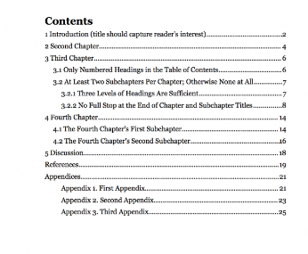

Sample table of contents

**Sequence of report:**

1. Front page
2. List of figures
3. List of tables
4. Table of contents
5. Problem definition
6. Introduction – Chapter 1
7. Modules and functionalities and their interconnection – Chapter 2
8. Implementation (code + screenshots of website) – Chapter 3
9. Conclusion & Future scope– Chapter 4
10. References

### Introduction:

The title of Chapter 1 shall be Introduction. It shall justify and highlight the problem posed, define the topic and explain the aim and scope of the work presented in the report. It may also highlight the significant contributions from the investigation.

*The Introduction tells the reader what the report is about. It sets the project in its wider context, and provides the background information the reader needs to understand the report.*

*The Introduction:*

* *Introduces the topic of the report in context*
* *Explains the problem and/or motivation for the project*
* *States the aim/s of the project*
* *Indicates the purpose of the report*
* *Briefly outlines the report structure (not necessary in a short report).*

**Paper & Typing dimension**

* The report should be typed in one side of the paper only.
* Use A4 size papers.
* Whole of the report (expect the cover and title page) should be typed in Times New Roman font size of 12, justified and a line spacing of 1.5.
* Left margin 3 cm, Right margin 2 cm.
* Top margin 2.5 cm and Bottom margin 3.5 cm to be maintained.
* Each chapter should start at a fresh page with a heading of a chapter.

**Pagination**

* All pages must be numbered consecutively as follows:
  + Lower-case Roman numerals (i.e., i, ii, iii, iv, v, vi, etc.) are used for preliminary pages (declaration, list of figures/tables, Table of contents etc.). The numerals appear in the right bottom corner of the page.
  + Arabic numerals (i.e., 1, 2, 3, 4, 5, 6, etc.) are used for the rest of the body of the report. The numerals appear in the right bottom corner of the page.

**Caption of figure & tables.**

Caption of figure and table should be provided at the bottom of the table and diagram. Captions should be italicized and should be at the center. Figure and table numbers should be in tune with the chapter numbers (e.g. the first figure of the chapter I should be numbered as Fig.1.1, first figure of chapter II should be numbered as Fig. 2.1 and so on.

**NOTE:**

--Use spiral binding to submit your report in hard copy and PDF format to submit it in soft copy.

--The front of the spiral binding should be transparent and the back should be black color.

--Every group will submit one hard copy report.